**Math 252 Homework 3 Written Part Name:______________________________**

*Write legibly. Show your work. Graph neatly. Use a ruler for all straight lines.*

1. By reading values from the given graph of g(x), use six rectangles to estimate . In each case, carefully draw the rectangles that you use. (Pay attention to the scale on the graph!)
   1. Left endpoints:

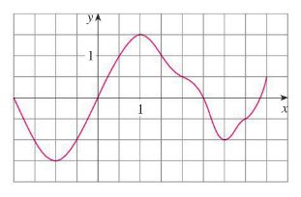

* 1. Right endpoints:



* 1. Midpoints:



1. A table of values for an increasing function f is shown. Use the table to find lower and upper estimates for . Use five subintervals.

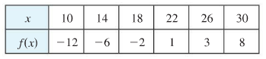

* 1. Lower estimate:
  2. Upper estimate:

1. Use a calculator or computer to make a table of values of midpoint Riemann sums (Mn) for the integral . (Don't round your answers.)

|  |  |
| --- | --- |
| **n** | **Mn** |
| 5 |  |
| 10 |  |
| 50 |  |
| 100 |  |

1. What number does the integral look like it's going to be?

= ______________